**User Manual**

**Full body motion tracking system**

**Group 20**

* Karunarthna D.A.D.T , E/16/173 , [e16173@eng.pdn.ac.lk](mailto:e16173@eng.pdn.ac.lk)
* Wijayasinghe S.D.D.D , E/16/394 , [e16394@eng.pdn.ac.lk](mailto:e16394@eng.pdn.ac.lk)
* Wijekoon W.M.T.S , E/16/396 , [e16396@eng.pdn.ac.lk](mailto:e16396@eng.pdn.ac.lk)

**GitHub repository link**

<https://github.com/cepdnaclk/e16-3yp-full-body-motion-tracking-system>

**1.0 Introduction**

Full body motion tracking system is a multiplayer first-person shooter game based on body motion of the players.

The aim of this this product is to improve gamer's sense of freedom of movement and feelings of immersion within the virtual environment while playing together over a greater distance to achieve a common goal.

This consists of the following components.

* **Controller** is used to provide player inputs.
* **VR Headset** is used provide virtual reality for the wearer.
* **Main Unit** is used to identify player actions
* **Game**

1. **User Interface**

**2.1 Main Menu**

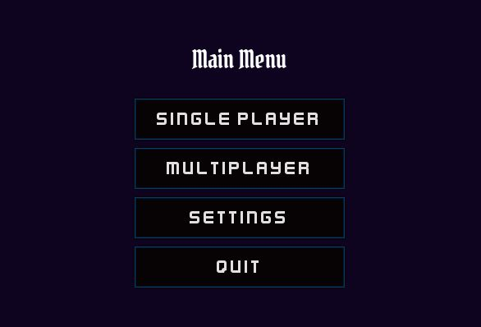

In the main menu you select whether to play single player mode or multiplayer mode.

**2.2 Login Screen**

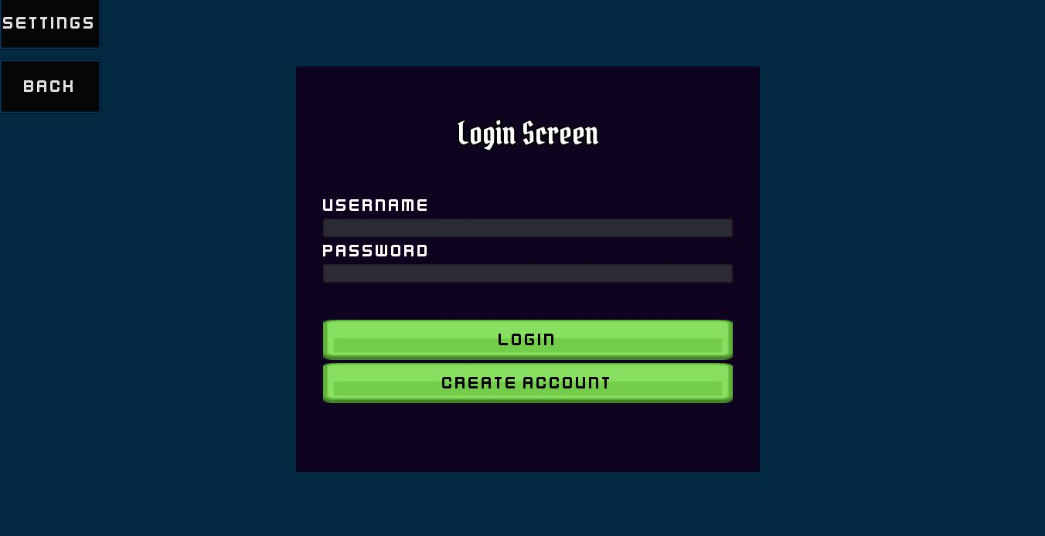

Next you can see the login screen and there you can login by providing your username and password.

**2.3 Create an account**

If you don’t have an account yet, then you can create an account also.

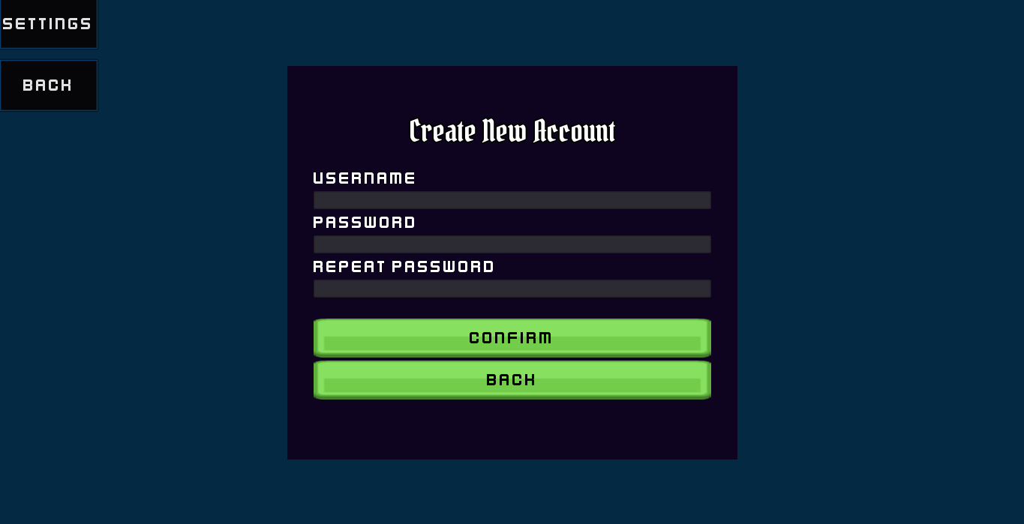

When creating a new account you should select a username as well as a password with at least 7 characters.

And also using settings tab you can configure settings related to game.

In addition, you can quit using quit tab.

1. **VR Headset**

**3.1 Overview**

In VR Headset main unit is already included for identifying actions of the player. And also you want to put your smart phone which is used for play the game.

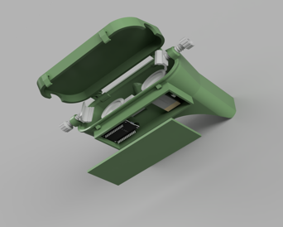

**4.2 Power**

1. **Controller**

**4.1 Overview**

Main objectives of the controller is to provide user inputs to the game using push button and actions by the player.

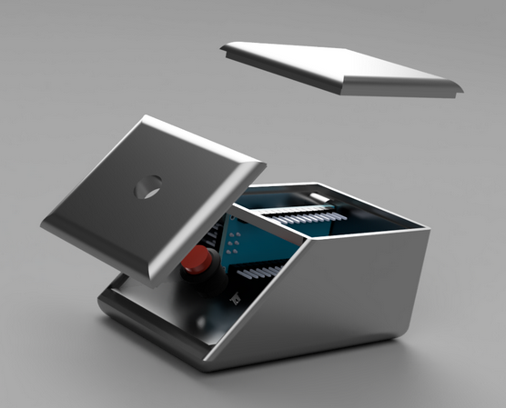

**4.2 Power**